Md.Areful Arefin

**Ans. To Ques. No-01(a):**

In MS Word , an **illustration** refers to any visual element, such as shapes, images, charts, or drawings, inserted to enhance the content.

It helps to clarify, emphasize, or decorate the text, making the document more engaging and informative.

**Purpose of using** : To make flowchart, network diagram.

………………………………………………………………………………………………….

**By using Pictures:**

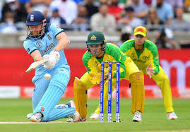

Figure: England and Australia Team playing Cricket.

………………………………………………………………………………………………….

**By using Online Pictures:**

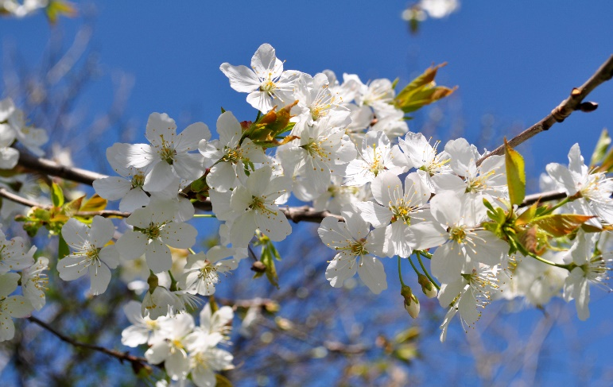

Figure: Flowers

………………………………………………………………………………………………….

**By using Shapes:**

Figure: Making of Bangladesh National Flag by Using Shapes

………………………………………………………………………………………………….

**By using Smart Art:**

The English word Jurisprudence is derived from the Latin, *jurisprudentia*. *juris* is the genitive form of *jus* meaning law, and *prudentia* meaning prudence .

………………………………………………………………………………………………….

**By using a Chart:**

………………………………………………………………………………………………….

**By using Screenshot:**

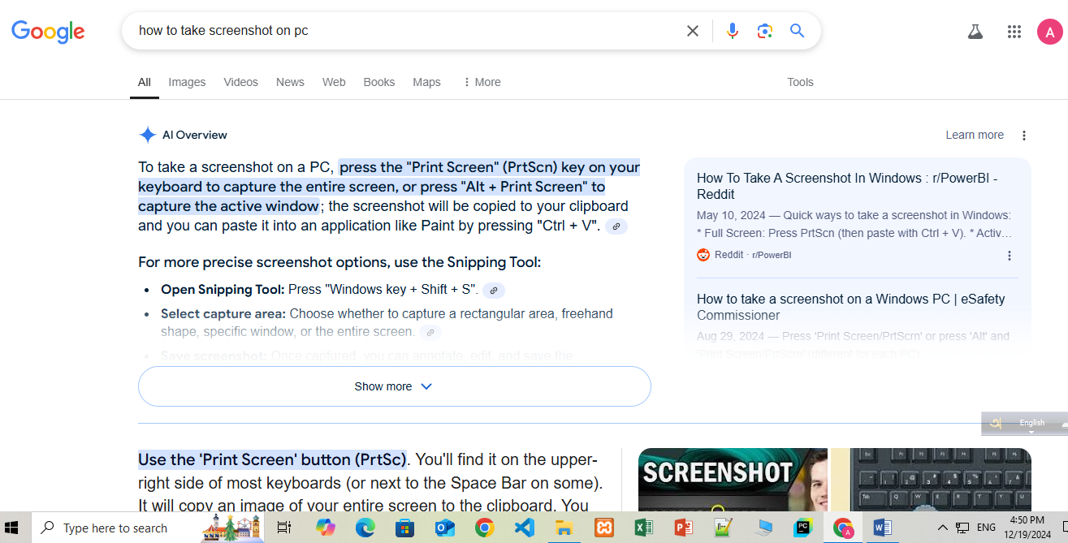

………………………………………………………………………………………………….

**Insert more than 2 shapes and Group and Ungroup the shapes:**

1. **Group:**
2. **Ungroup:**

………………………………………………………………………………………………….

………………………………………………………………………………………………….

**Ans. To Ques. No-01(b):**

**Keep 2/2 inches left and right indeed:**

Left:

Law is a set of rules that are created and are enforceable by social or governmental institutions to regulate behavior, with its precise definition a matter of longstanding debate.It has been variously described as a science and as the art of justice. State-enforced laws can be made by a legislature, resulting in statutes; by the executive through decrees and regulations; or by judges' decisions, which form precedent in common law jurisdictions. An autocrat may exercise those functions within their realm.

Right:

Law is a set of rules that are created and are enforceable by social or governmental institutions to regulate behavior, with its precise definition a matter of longstanding debate.It has been variously described as a science and as the art of justice. State-enforced laws can be made by a legislature, resulting in statutes; by the executive through decrees and regulations; or by judges' decisions, which form precedent in common law jurisdictions. An autocrat may exercise those functions within their realm.

………………………………………………………………………………………………….

**Insert “Word processing Question” as header and page number in the footer:**

Header:

Using “**Word processing Question”** as header

Footer:

Enter Page number in Footer

………………………………………………………………………………………………….

**Insert “Practical Preparation” in the Right Margin of Document in Vertical alignment Orientation:**

**“Practical Preparation”**

………………………………………………………………………………………………….

………………………………………………………………………………………………….

**Ans. To Ques. No-01(c):**

………………………………………………………………………………………………….

………………………………………………………………………………………………….

**Ans. To Ques. No-01(d):**

|  |  |  |  |  |
| --- | --- | --- | --- | --- |
| January Test | | | | |
| Surname | Name | English | German | Computer |
| Xuereb | Nobert | 85 | 42 | 98 |
| Spiteri | Richard | 53 | 45 | 75 |
| Borg | Clive | 55 | 85 | 82 |
| Caruana | Michelle | 45 | 45 | 25 |

**1)**

|  |  |  |  |  |
| --- | --- | --- | --- | --- |
| January Test | | | | |
| Surname | Name | English | German | Computer |
| Xuereb | Nobert | 85 | 42 | 98 |
| Spiteri | Richard | 53 | 45 | 75 |
| Briffa | Paola | 42 | 25 | 48 |
| Borg | Clive | 55 | 85 | 82 |
| Caruana | Michelle | 45 | 45 | 25 |

**2)**

|  |  |  |  |  |
| --- | --- | --- | --- | --- |
| January Test | | | | |
| Surname | Name | English | German | Computer |
| Xuereb | Nobert | 85 | 42 | 98 |
| Spiteri | Richard | 53 | 45 | 75 |
| Borg | Clive | 55 | 85 | 82 |
| Caruana | Michelle | 45 | 45 | 25 |

**3)**

|  |  |  |  |  |
| --- | --- | --- | --- | --- |
| January Test | | | | |
| Surname | Name | English | German | Computer |
| XUEREB | Nobert | 85 | 42 | 98 |
| Spiteri | Richard | 53 | 45 | 75 |
| Borg | Clive | 55 | 85 | 82 |
| Caruana | Michelle | 45 | 45 | 25 |

**4)**

|  |  |  |  |  |
| --- | --- | --- | --- | --- |
| January Test | | | | |
| Surname | Name | English | German | Computer |
| Xuereb | Nobert | 85 | 42 | 98 |
| Spiteri | Richard | 53 | 45 | 75 |
| Borg | Clive | 55 | 85 | 82 |
| Caruana | Michelle | 45 | 45 | 25 |

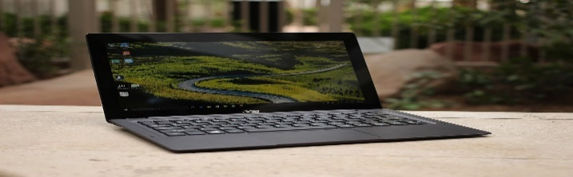

[This Photo](https://en.wikipedia.org/wiki/Acer_Aspire) by Unknown Author is licensed under [CC BY-SA](https://creativecommons.org/licenses/by-sa/3.0/)

**5)**

|  |  |  |  |  |
| --- | --- | --- | --- | --- |
| January Test | | | | |
| Surname | Name | English | German | Computer |
| Xuereb | Nobert | 85 | 42 | 98 |
| Spiteri | Richard | 53 | 45 | 75 |
| Borg | Clive | 55 | 85 | 82 |

|  |  |  |  |  |
| --- | --- | --- | --- | --- |
| Caruana | Michelle | 45 | 45 | 25 |